1. **Note**: Our app is both
   1. Resource Owner.
   2. Client
2. 
3. 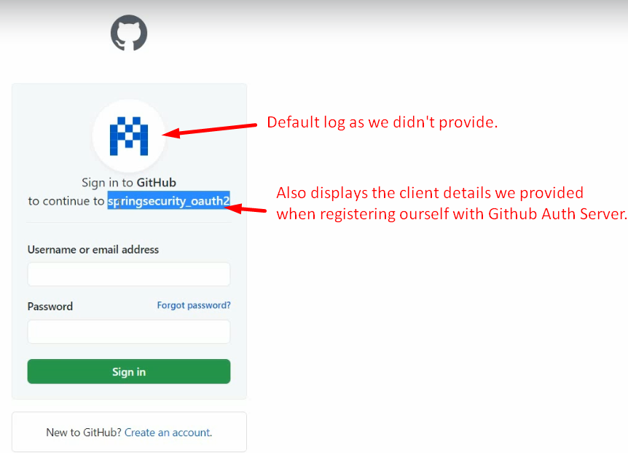
4. 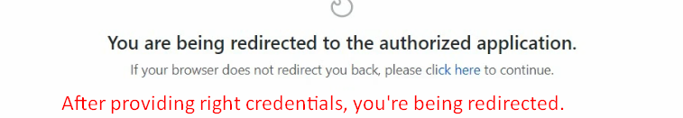
5. 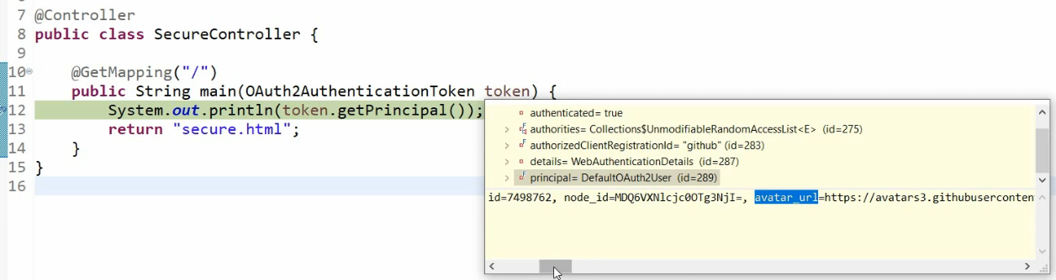
6. 